Manage your activities

# How data is handled?

The application will persist the content locally, to be able to allow offline access. When it is online, it will synchronize the content with a remote server.

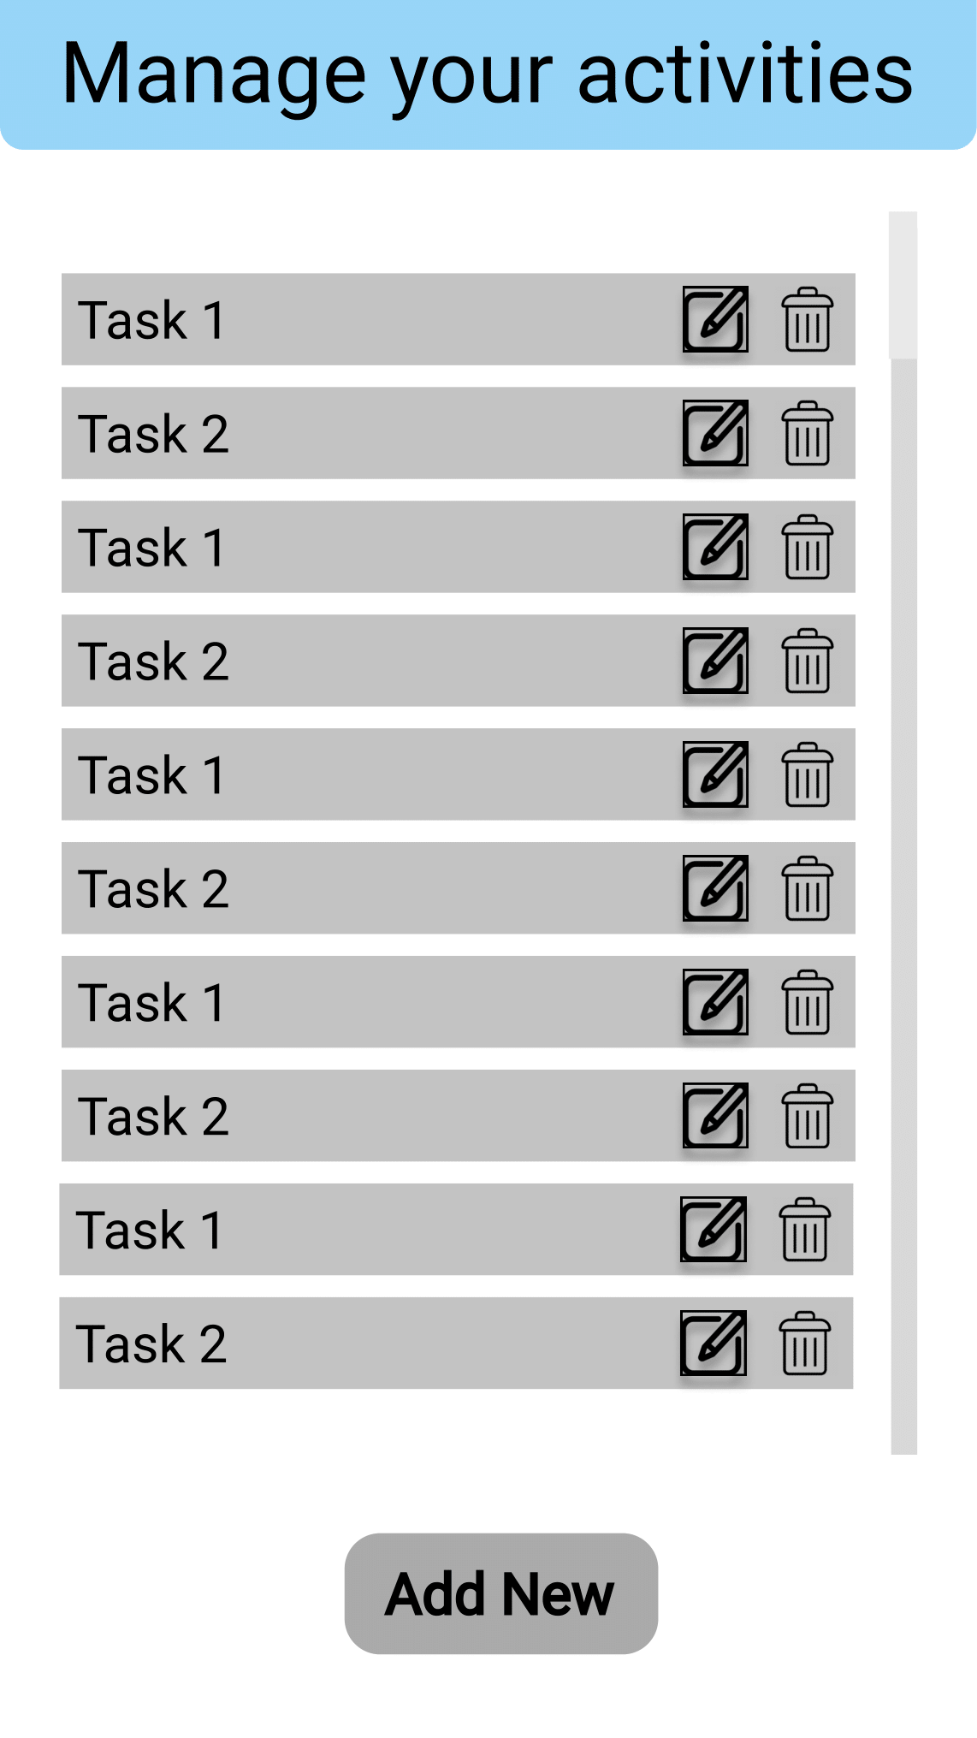

# Main Screen

When the application starts, the user is met with the list of activities from their database.

# 

# Create

To create a new entry, tap the “Add New” button from the main screen. This button will bring you to another window where you can create and add the new activity to the database.

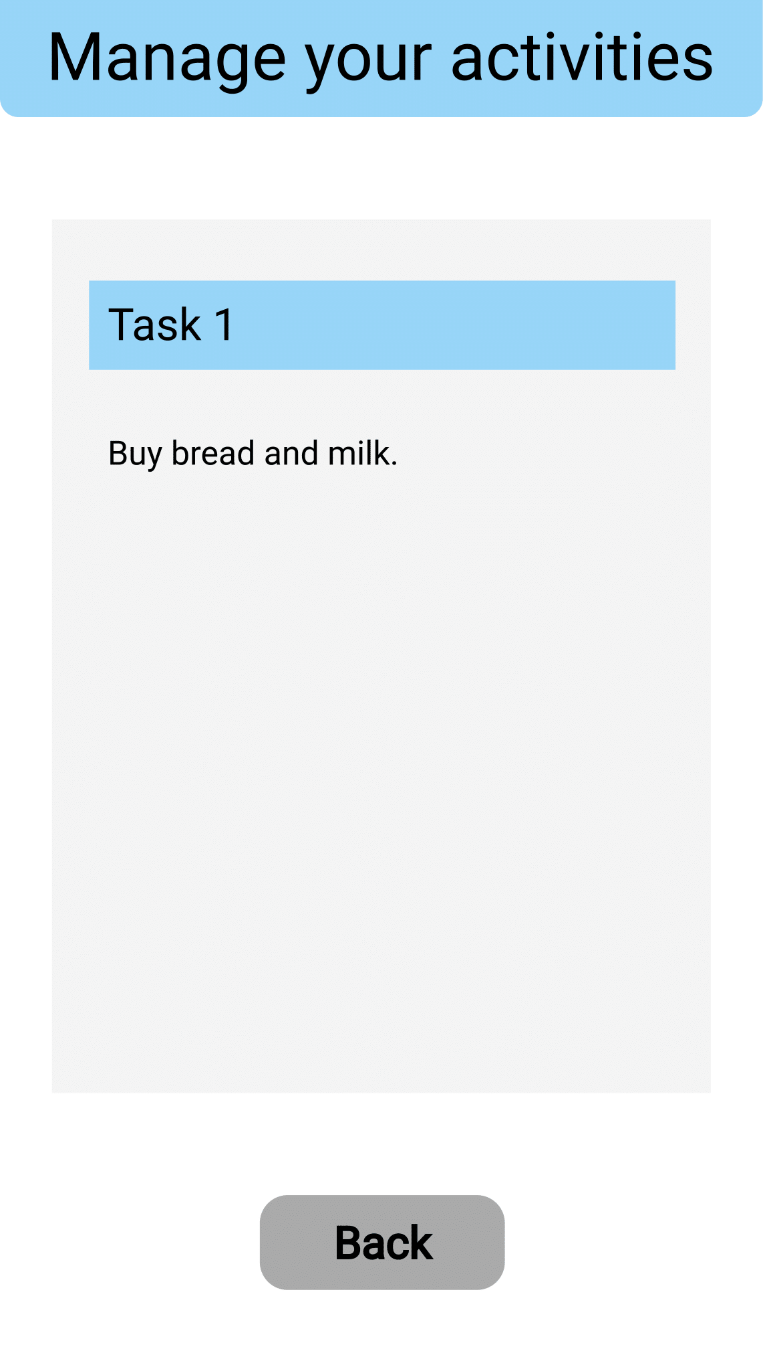

# Read

In case you want to read the details of one of your activities, you can just tap on one of them from the list and you’ll be brought to another window with that task’s details.

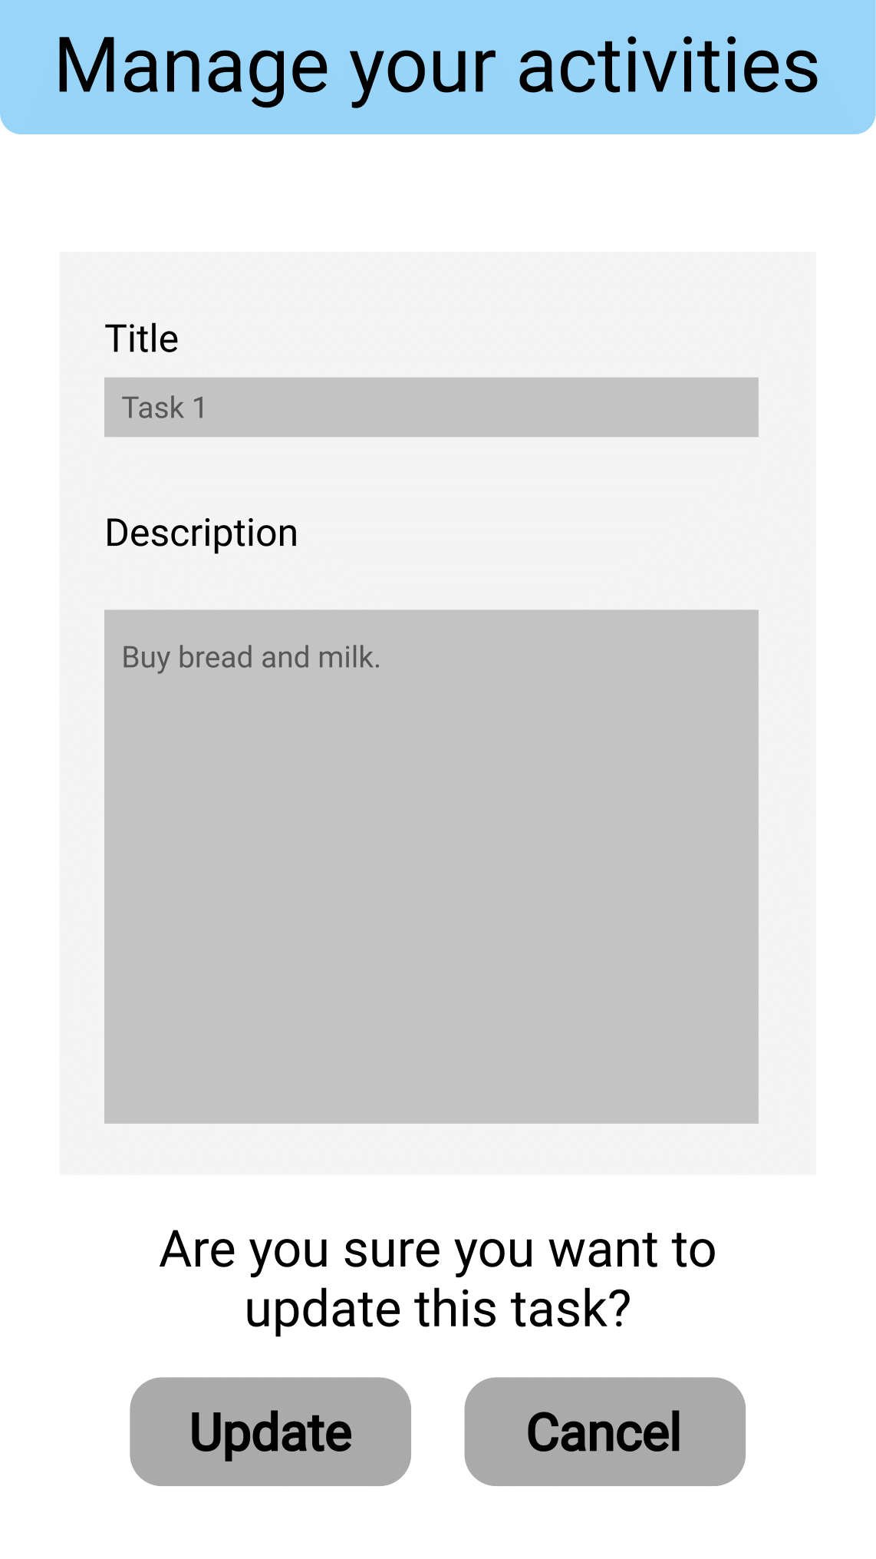

# Update

To edit one of the activities press the edit icon ( ) next to it’s name on the main screen and you’ll get to the update window.

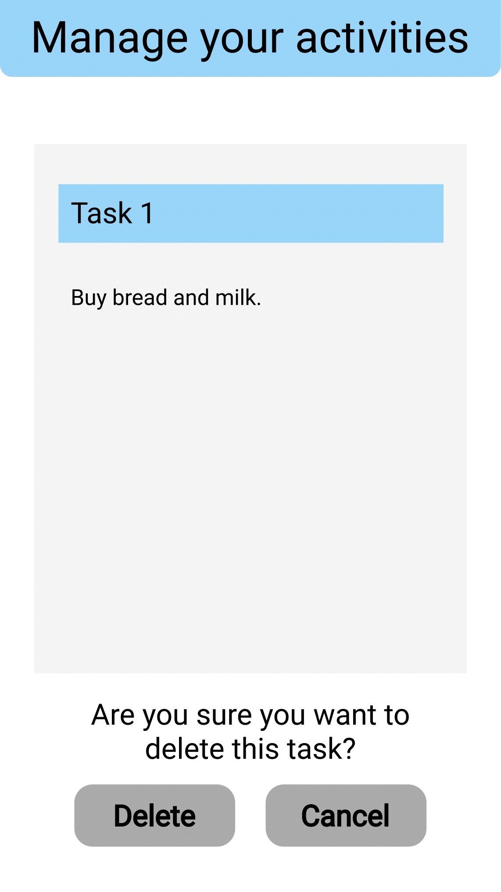

# Delete

To delete one of the tasks, tap the trash bin icon () next to it’s name on the main screen and you’ll go to the delete window.

# Offline mode

On update and delete - a message will be displayed, that the application is offline and the operation is not available.

On read - the content from the local database will be displayed.

On create - the input will be persisted in the local database and when the application will detect that the device is able to connect to the server, it will push all the created entries from when the device was offline.